Questions shared by onsite:

**Exercise 1**. XPath/CSS

Visit Page: <https://www.cengage.com/careers/>

1.1. Write a locator (XPath/CSS) that will select all top frame labels/tabs "Students", "Instructors", "Administrators", "More…" (question was reframed as – you need to write the xpath such that the entire list is captured and can be stored inside a list of WebElements)

Notes: Expected XPath “//li[contains(@class,"ceng-headerNavMain_navItem ")]/a”

1.2. Modify locator so that now it will find only "Administrators"

Notes: (//li[@class='ceng-headerNavMain_navItem ']/a)[3]

**Exercise 2**. XPath/CSS

Visit Page: <https://www.cengage.com/careers/> and navigate to **FAQ**. Open “Life at Cengage” drop down

2.1. Write a locator (XPath/CSS) that will select "How do you support work-life balance?"

Notes: Expected XPath “//a[text()='How do you support work-life balance?']”

2.2. Now write a locator (XPath/CSS) that will select sibling item to “How do you support work-life balance?” labeled “Do you offer benefits?”

Notes:

//a[text()='How do you support work-life balance?']/parent::*/parent::*/preceding-sibling::*[@class='ceng-z_title'][1]/h3/a

2.3. Now write a locator (XPath/CSS) that will select parent item to “How do you support work-life balance?” labeled “Life at Cengage”

Notes: Expected XPath “//a[text()="How do you support work-life balance?"]/ancestor::*[@class="ceng-accordion_content ng-scope"]/preceding-sibling::*[@class="ceng-accordion_title"][1]//a”

//a[text()='How do you support work-life balance?']/ancestor::*[@class='ceng-accordion_content ng-scope']/preceding-sibling::*[@class='ceng-accordion_title'][1]

**Exercise 3**. Java

Go to <https://codeinterview.io/YKJDTERNYJ> and write the code to reverse **Words Sequence**

Notes:

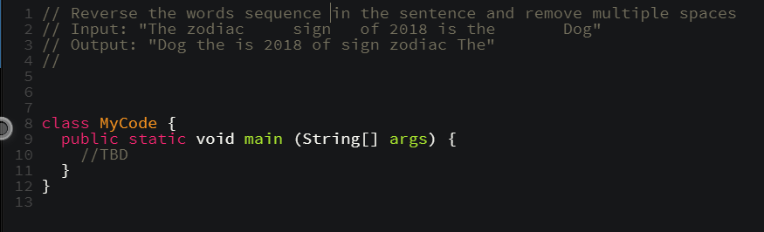

**~~E~~xercise 4**. Java

Go to <https://codeinterview.io/GWXTEMLHCS> and write the code to implement ***ThreeFive*** algorithm

Notes:

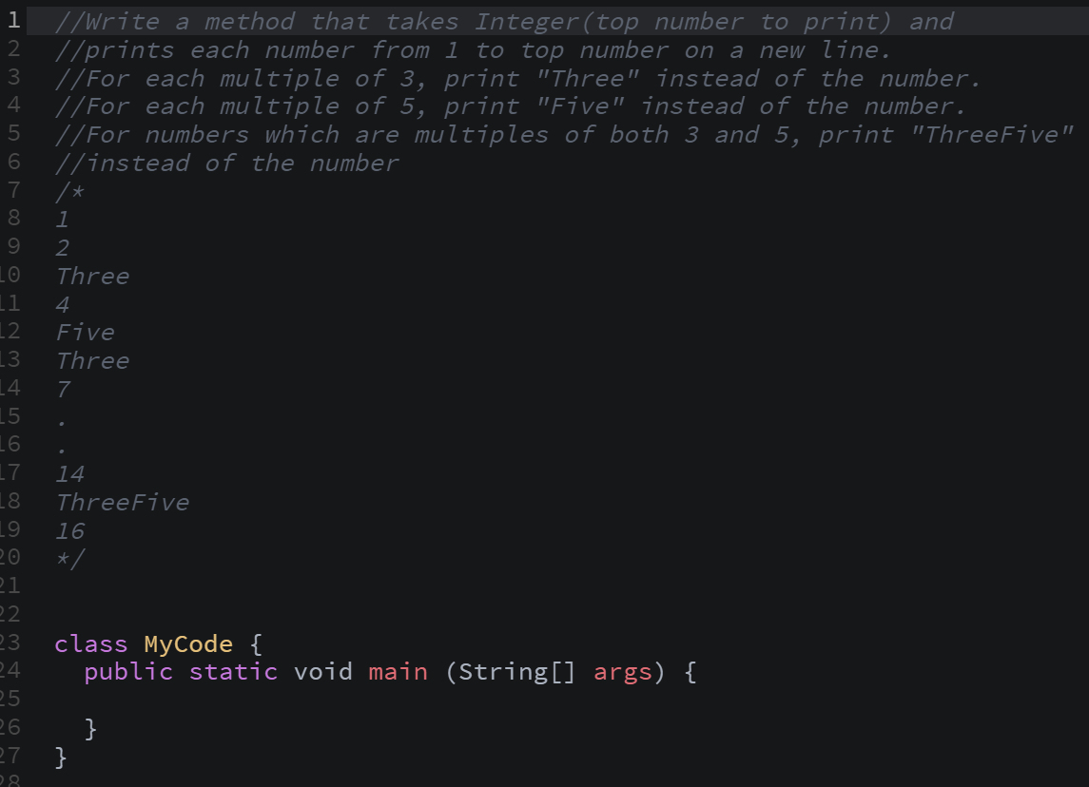

**Exercise 5**. Java

Go to <https://codeinterview.io/ZXWUKMCRGY> and write the code to implement *isBalanced()*

Notes:

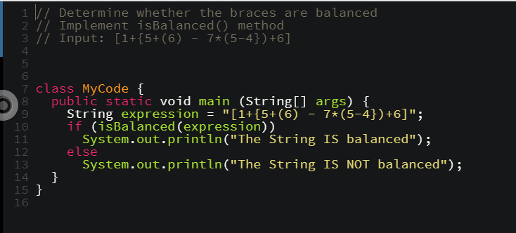

August 10 2018:

1. What is Page object model and what are the advantages of using it?
2. What is TestNG framework and how is it useful in automating test cases?
3. What are maven projects and what is the use of a POM.xml file in maven ?
4. Is it possible to create a TestNG project as a maven?
5. What is method overloading and method overriding in java?
6. Is it possible to override private and static methods in java ?
7. How do we handle a dropdown in selenium?
8. How do you handle test data in automation frameworks?
9. Consider  a scenario that you have found out that there a new and effective way in implementing a logical flow than how its currently implemented , what would you do in such a scenario ?
10. How to identify parent and child elements using a child element in selenium?
11. What are the regular expressions that can be used in xpath in selenium?
12. Write a program to check whether the string is balanced or not ? (Live Coding session using code pad)
13. Asked to identify an element group and parent element using the child element in cengage.com?

Sept 21 2018

1. How do you look whether page or DOM is properly loaded?
2. Different types of wait (implicit, fluent, explicit),when you go for each?
3. Maven and Page Object Modelling
4. Advantages of Page Object Modelling
5. How you have used Page Object Modelling in your project?
6. Testng advantages
7. Finding xpath on [www.cengage.com/careers](http://www.cengage.com/careers)( they are looking for xpaths having ancestor/siblings/using key word contains)
8. Method overloading and method over riding in java.
9. Different type of data types in java.
10. Program to reverse a sentence. Example: India is my country/country my is India
11. write the code to implement isBalanced()

30th January 2019

1. Given you need to test the following flow: load Login Page, login using given credentials, verify presence of some Text on a Home Page, logout. How would you write test automation for it? -> Design approach, structure
2. **Page Object Model** (POM) - What is it and how it is used in Web UI automated tests?
3. If you need to locate an element on a page that may not be present, what Selenium method would you use? (If the element is not there, what would findElement() return and what would findElements() return?)
4. What is the difference between implicit, explicit and fluent wait in Selenium?
5. What kind of Locators you may use with Selenium to find an element? (Do you know of any strengths or weaknesses of XPath or CSS? Which one would you use to find a parent node of a given element?)
6. What is a relative and an absolute path?
7. TestNG - What is it and how would you use it?
8. Does TestNG support Multi-threaded testing/parallel testing/load testing?
9. Ways in which TestNG can be invoked?
10. What is testng.xml file used for?
11. Maven - What is it? Where and how it is used?
12. What is POM file and how is it used?
13. Jenkins - What is it and how would you use it in your testing?
14. How would you parametrize a Jenkins job? Advantages of a job parametrization
15. Java Primitive vs Object data types - What is the difference? Can you give example of both?
16. What is Overloading? What can you overload? What are advantages of using overloading?
17. What is Overriding? What can you override? What are advantages of using overriding?
18. Git – What is it and how do you use it?
19. How would you resolve merging conflicts?
20. Asked to identify an element group and parent element using the child element in cengage.com?
21. * symbol used in xpath
22. Live coding for reversing a sentence

20th February 2019

1. Live coding to implement isBalanced() method to verify whether the parenthesis are balanced
2. Xpath expressions – exercise 1, exercise 2, exercise 3
3. Do you have experience in creating framework on your own.? If yes, just brief on the framework (not in detail but should touch base how POM framework is implemented)
4. What is page factory? How can you use it while creating a POM framework?
5. How do you randomly switch the control from one window to another?
6. What is TestNG and what are the advantages of using TestNG.
7. Can we use String functions with Xpath?
8. Can we use regEx with Xpath? How?
9. What is the difference between relative and absolute Xpath? Which one is efficient and why?
10. Which one do you prefer – Css or Xpath? Why?
11. Why do we use ‘.’ And ‘*’ in Xpath?
12. How comfortable are you in Maven?. What are the advantages of having a Maven project?
13. What does POM.xml contain? ( explain on dependency, plugin, build etc.)
14. What is Jenkins and what is it used for?
15. Java Primitive vs Object data types - What is the difference?
16. What is Overloading? What all can be overloaded? (Constructor, method)
17. Difference between Abstract classes and interfaces
18. What is Git? Explain on how you used git in your project (Create branch, fetch, pull, commit, push, merge to master/release branch)
19. How did you resolve merge conflict? Explain with a scenario.
20. Do you have idea on extent reports? What do you know about extent reports (report – startTest(). endTest(), flush(), test – log(LogStatus.Pass,””) etc.
21. How can we generate html reports.? Can we integrate extent reports and html reports.

Additional questions:

1. Please describe your day to day responsibilities
2. Test a program that spells out entered integer numbers (converts integer numbers to words (example: 15 becomes fifteen)). What are some of the test cases you would use to test if it works correctly?
3. Given you need to test the following flow: load Login Page, login using given credentials, verify presence of some Text on a Home Page, logout.

How would you test it? -> list of test cases

1. Page Factory - What is it and how it is used?
2. How would you define BDD?
3. Who should write scenarions for BDD?
4. What is Gherkin and how it is used with BDD?
5. What is a feature file and what does it contain?
6. What is your level of experience in Selenium from 1 to 10?
7. What is a dynamic page/content and how would you work with it? (Expectation: page is getting updated via AJAX, React, SJ running on client side without pet/post interaction with server: Weather Channel, Odometer)
8. Please explain what PageFactory is and how it is used with POM. Annotation examples.
9. Please explain what is AjaxElementLocatorFactory and how it is used.
10. What is StaleElementException? Under what conditions you may get one?
11. In Selenium - How to switch to a top frame at any time?
12. How to work with multiple browser windows/tabs? (How would you locate and switch to a specific one?)
13. Can Selenium run a Java Script snippet? (If yes then how?)
14. Given you need to open an URL in Chrome browser with Selenium WebDriver, what Libraries, API calls, instances would you need? (How would you start selenium session, open browser page, close browser, close selenium session?)
15. Can you use wildcards with XPath? With CSS?
16. Can you use String functions with XPath? Which ones?
17. Can you use axes with XPath? How?
18. Can you use logical operators with XPath? Examples?
19. How can you enable parallel test run using TestNG?
20. What is testng.xml file used for?
21. What is POM file and how is it used?
22. Can you specify 2 different versions for the same library in a POM file? If yes then how?
23. What ways of test execution via Jenkins you know of?
24. What popular Jenkins features or plugins you know of?
25. If you do not specify a visibility modifier, which default visibility scope is assigned in Java?
26. Can you override a private or a static method?
27. Polymorphism: What is it and how is it used?
28. Abstract class vs Interface - What is similar, and what is different? When you would use one or another?
29. Java synchronous vs asynchronous collections – what is the main difference? Which one will you use for multi-threaded access?
30. Multiple Inheritance - How would you implement it?
31. What is a Garbage Collector? How it works? Can you change the default GC to a different one?
32. Can you get memory leaks when using Java? If yes when how? How would you find a memory leak?
33. Java 8 features: Lambda expressions
34. Java 8 features: Stream API
35. You made some changes to your code in your feature branch. Name Git commands you need to use to add your changes to release branch.

**April 30 -2019**

1. **Exercise 1:** Write a program JAVA program to print a string in given format without extra spaces in the Input string.



1. **Exercise 2:** Write a locator path that will select all top frame labels/tabs "Students", "Instructors", "Administrators", "More…"
2. **Exercise 3:** Visit Page: <https://www.cengage.com/careers/> and navigate to **FAQ**. Open “Life at Cengage” drop down. Write a locator (XPath/CSS) that will select "How do you support work-life balance?"
3. **Exercise 4:** Now write a locator (XPath/CSS) that will select “Life at Cengage” using the previous xpath created for “How do you support work-life balance?"
4. Explain your framework & Design of Automation you have done in your project.
5. What is POM? Explain
6. How you design a Framework/Design if we need to test load Login Page, login using given credentials, verify presence of some Text on a Home Page, logout
7. Difference between Abstract class & Interface
8. What is Garbage Collector? What it does?
9. When the Memory leakage Happens?
10. How do you Manage/resolve Memory leakage?
11. Can you override a private or a static method?
12. Method Overriding & example
13. Which locator would you prefer?
14. Can we navigate up or down through nodes using CSS & Xpath
15. How you handle a dynamic content of Webpage?
16. What are the waits available in selenium?
17. Is call By Value & Call by Reference is possible in JAVA
18. What is primitive & Non primitive Data Types
19. Have you worked on Lambda & Stream APIs
20. How can you achieve Parallel Testing in TestNG
21. What are the Annotations available in TestNG and used in your Project
22. How you achieve dependency & Grouping of Test cases.
23. What is Data provider? Usage & explain
24. What is Maven? Why & usage explain.
25. What do you know about Jenkins?
26. What is GIT? Usage
27. What are the branches in project
28. How would you resolve, if conflicts occur when merging?
29. What is Jenkins? How do you used it?